## UI/UX design for the Mobile Application:

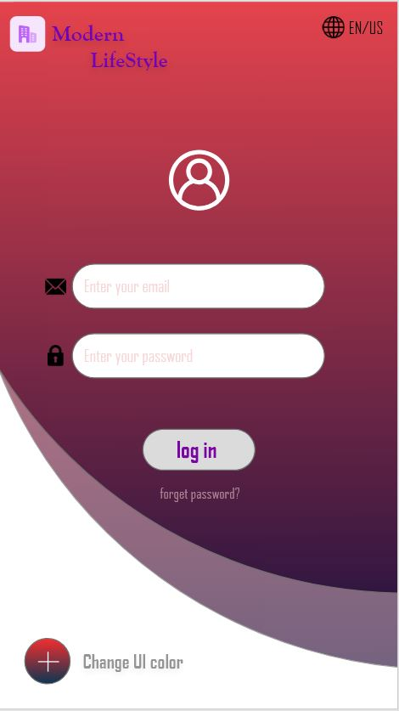

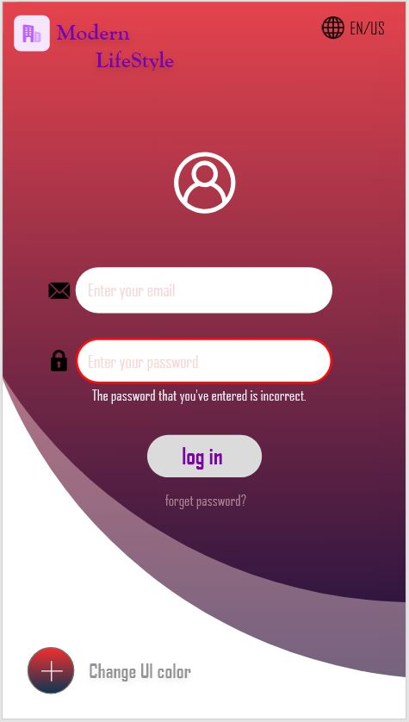

**Fig 1: Log in page Fig 2: Incorrect Password page**

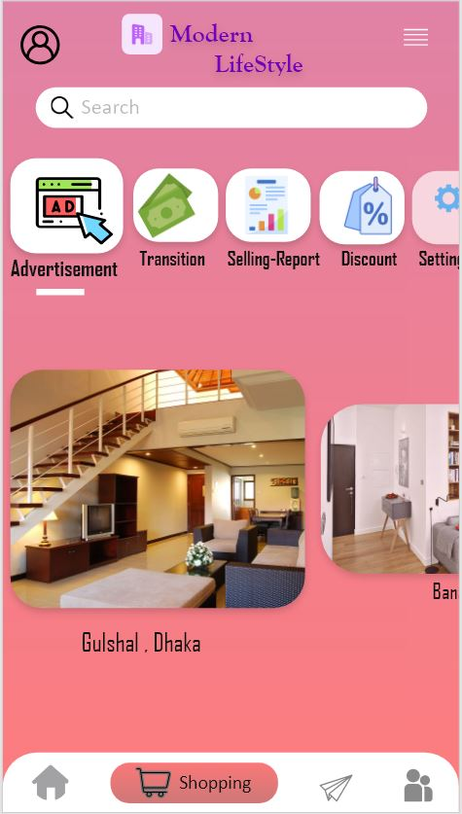 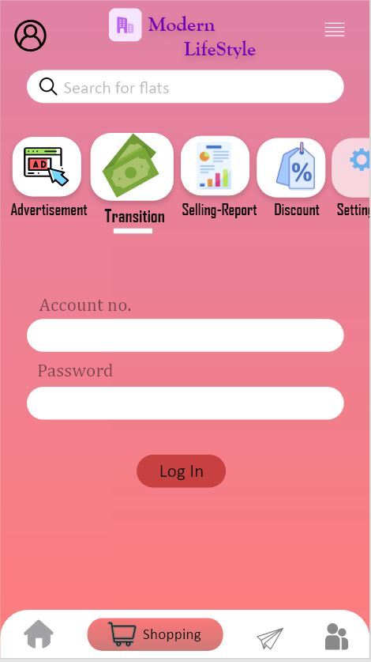  
 **Fig 3: Advertisement page** **Fig 4: Transition page**

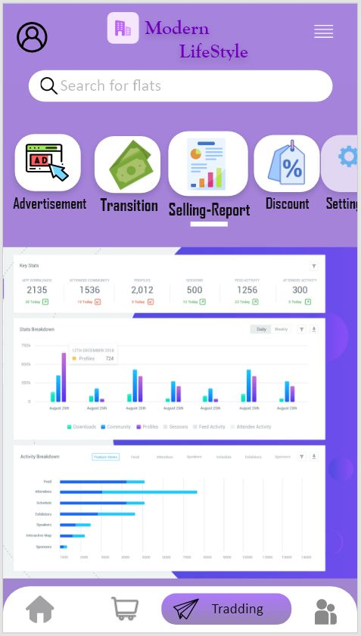 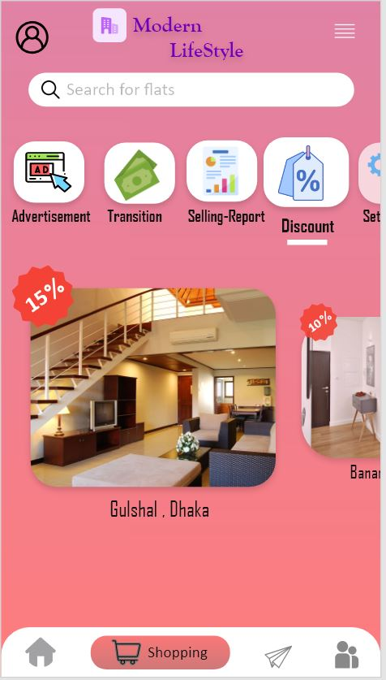

**Fig 5: Selling-Report page Fig 6: Discount page**

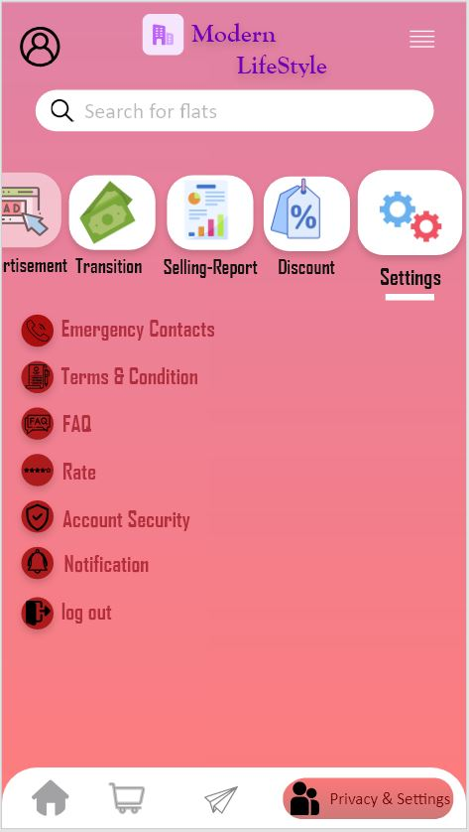

**Fig 7: Settings page**